

**Laboratory Manual**

**17CSL77-WEB TECHNOLOGY LABORATORY WITH MINI PROJECT**

**Student USN:_____________________________________**

**Student Name:___________________________________**

**Department of Computer Science and Engineering**

**ASKB Campus, 1st Main, AGS Colony**

**Anandnagar, Bengaluru - 560024**

**Karnataka**

**2020-2021**

|  |  |
| --- | --- |
| Web Technology Laboratory With Mini Project | 17CSL77 |
|  |  |

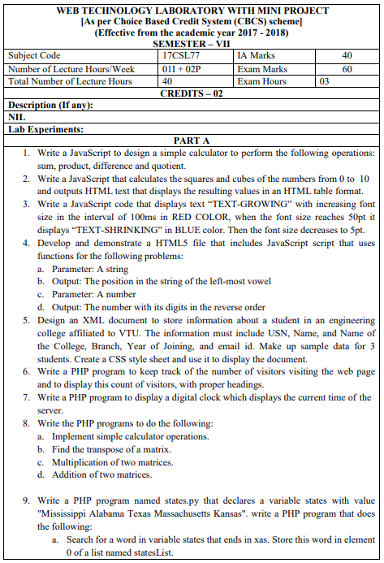

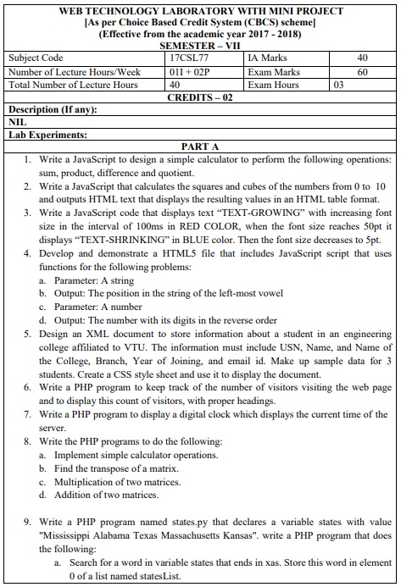

|  |  |
| --- | --- |
| Web Technology Laboratory With Mini Project | 17CSL77 |
|  |  |

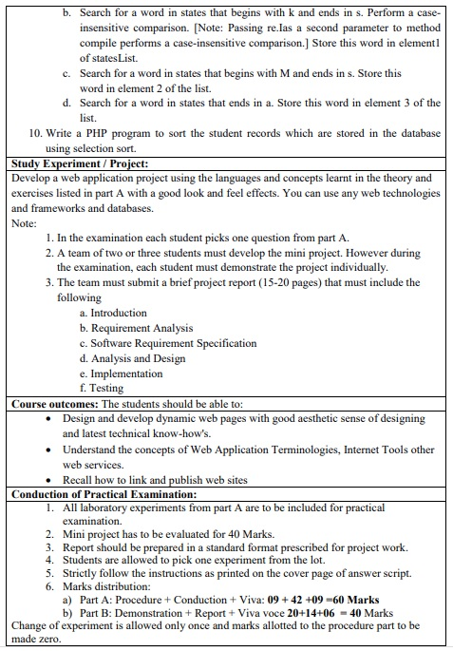

Department of CS&E Page 3

|  |  |
| --- | --- |
| Web Technology Laboratory With Mini Project | 17CSL77 |
|  |  |



**WEB TECHNOLOGY LABORATORY WITH MINI PROJECT** [As per Choice Based Credit System (CBCS) scheme] (Effective from the academic year 2017 -2018) **SEMESTER – VII**

|  |  |  |  |
| --- | --- | --- | --- |
| **Subject Code** | 17CSL77 | **IA Marks** | 40 |
|  |  |  |  |
| **Number of Lecture Hours/Week** | 01I + 02P | **Exam Marks** | 60 |
|  |  |  |  |
| **Total Number of Lecture Hours** | 40 | **Exam Hours** | 03 |
|  |  |  |  |

1. Write a JavaScript to design a simple calculator to perform the following operations: sum, product, difference and quotient.
2. Write a JavaScript that calculates the squares and cubes of the numbers from 0 to 10and outputs HTML text that displays the resulting values in an HTML table format.
3. Write a JavaScript code that displays text “TEXT-GROWING” with increasing font size in the interval of 100ms in RED COLOR, when the font size reaches 50pt it displays “TEXT-SHRINKING” in BLUE color. Then the font size decreases to 5pt.
4. Develop and demonstrate a HTML5 file that includes JavaScript script that uses functions for the following problems:
   1. Parameter: A string
   2. Output: The position in the string of the left-most vowel
   3. Parameter: A number
   4. Output: The number with its digits in the reverse order
5. Design an XML document to store information about a student in an engineering college affiliated to VTU. The information must include USN, Name, and Name of the College, Branch, Year of Joining, and email id. Make up sample data for 3students. Create a CSS style sheet and use it to display the document.



Department of CS&E Page 4

|  |  |
| --- | --- |
| Web Technology Laboratory With Mini Project | 17CSL77 |
|  |  |

1. Write a PHP program to keep track of the number of visitors visiting the web page and to display this count of visitors, with proper headings.
2. Write a PHP program to display a digital clock which displays the current time of the server.
3. Write the PHP programs to do the following:
   1. Implement simple calculator operations.
   2. Find the transpose of a matrix.
   3. Multiplication of two matrices.
   4. Addition of two matrices.
4. Write a PHP program named states.py that declares a variable states with value “Mississippi Alabama Texas Massachusetts Kansas". write a PHP program that does the following:
   1. Search for a word in variable states that ends in xas. Store this word in element0 of a list named states List.
   2. Search for a word in states that begins with k and ends in s. Perform a case-insensitive comparison. [Note: Passing re.Ias a second parameter to method compile performs a case-insensitive comparison.] Store this word in element1of states List.
   3. Search for a word in states that begins with M and ends in s. Store this word in element 2 of the list.
   4. Search for a word in states that ends in a. Store this word in element 3 of the list.
5. Write a PHP program to sort the student records which are stored in the database using selection sort.



Department of CS&E Page 5

|  |  |
| --- | --- |
| Web Technology Laboratory With Mini Project | 17CSL77 |
|  |  |

**Study Experiment / Project:**

Develop a web application project using the languages and concepts learnt in the theory and Exercises listed in part A with a good look and feel effects. You can use any web technologies and frameworks and databases.

**Note:**

1. In the examination each student picks one question from part A.
2. A team of two or three students must develop the mini project. However duringthe examination, each student must demonstrate the project individually.
3. The team must submit a brief project report (15-20 pages) that must include thefollowing:
   1. Introduction
   2. Requirement Analysis
   3. Software Requirement Specification
   4. Analysis and Design
   5. Implementation
   6. Testing

**Course outcomes:** The students should be able to:

* Design and develop dynamic web pages with good aesthetic sense of designing and latest technical know-how's.
* Have a good understanding of Web Application Terminologies, Internet Tools other web services.



Department of CS&E Page 6

|  |  |
| --- | --- |
| Web Technology Laboratory With Mini Project | 17CSL77 |
|  |  |

* Learn how to link and publish web sites

‘’’’’’’’’’’’’’’’’’

**Conduction of Practical Examination:**

1. All laboratory experiments from part A are to be included for practical examination.
2. Mini project has to be evaluated for 40 Marks.
3. Report should be prepared in a standard format prescribed for project work.
4. Students are allowed to pick one experiment from the lot.
5. Strictly follow the instructions as printed on the cover page of answer script.
6. Marks distribution:
   1. Part A: Procedure + Conduction + Viva: 09 + 42 +09 =60 Marks
   2. Part B: Demonstration + Report + Viva voce 20+14+06 = 40

**Marks Change of experiment is allowed only once and marks allotted to the procedure part to be made zero**.



Department of CS&E Page 7

|  |  |
| --- | --- |
| Web Technology Laboratory With Mini Project | 17CSL77 |
|  |  |

**Text Books:**

1. Randy Connolly, Ricardo Hoar, "Fundamentals of Web Development”, 1stEdition,

Pearson Education India. (ISBN:978-9332575271)

**Reference Books:**

1. Robin Nixon, “Learning PHP, MySQL &JavaScript with jQuery, CSS and HTML5”, 4thEdition, O’Reilly Publications, 2015. (ISBN:978-9352130153)
2. Luke Welling, Laura Thomson, “PHP and MySQL Web Development”, 5th Edition,

Pearson Education, 2016. (ISBN:978-9332582736)

1. Nicholas C Zakas, “Professional JavaScript for Web Developers”, 3rd Edition,
2. David Sawyer Mcfarland, “JavaScript & jQuery: The Missing Manual”, 1st Edition, O’Reilly/Shroff Publishers & Distributors Pvt Ltd, 2014 (ISBN:9789351108078)
3. Zak Ruvalcaba Anne Boehm, “Murach's HTML5 and CSS3”, 3rdEdition,

Murachs/Shroff Publishers & Distributors Pvt Ltd, 2016. (ISBN:978-9352133246)



Department of CS&E Page 8

|  |  |
| --- | --- |
| Web Technology Laboratory With Mini Project | 17CSL77 |
|  |  |

**Contents**

|  |  |  |  |  |  |
| --- | --- | --- | --- | --- | --- |
|  | Sl.No |  | Program | Page |  |
|  |  |  |  | No |  |
|  | 1 | Write a JavaScript to design a simple calculator to perform the following | | 12 |  |
|  |  | operations: sum, product, difference and quotient. | |  |  |
|  |  |  | |  |  |
|  | 2 | Write a JavaScript that calculates the squares and cubes of the numbers from | | 15 |  |
|  |  | 0 to 10and outputs HTML text that displays the resulting values in an | |  |  |
|  |  | HTML table format. | |  |  |
|  |  |  | |  |  |
|  | 3 | Write a JavaScript code that displays text “TEXT-GROWING” with | | 17 |  |
|  |  | increasing font size in the interval of 100ms in RED COLOR, when the font | |  |  |
|  |  | size reaches 50pt it displays “TEXT-SHRINKING” in BLUE color. Then | |  |  |
|  |  | the font size decreases to 5pt. | |  |  |
|  |  |  | |  |  |
|  | 4 | Develop and demonstrate a HTML5 file that includes JavaScript script that | | 19 |  |
|  |  | uses functions for the following problems: | |  |  |
|  |  | **a)** | Parameter: A string |  |  |
|  |  | **b)** | Output: The position in the string of the left-most vowel |  |  |
|  |  | **c)** | Parameter: A number |  |  |
|  |  | d) Output: The number with its digits in the reverse order | |  |  |
|  |  |  | |  |  |
|  | 5 | Design an XML document to store information about a student in an | | 23 |  |
|  |  | engineering college affiliated to VTU. The information must include USN, | |  |  |
|  |  | Name, and Name of the College, Branch, Year of Joining, and email id. | |  |  |
|  |  | Make up sample data for 3students. Create a CSS style sheet and use it to | |  |  |
|  |  | display the document. | |  |  |
|  |  |  | |  |  |
|  | 6 | Write a PHP program to keep track of the number of visitors visiting the | | 24 |  |
|  |  | web page and to display this count of visitors, with proper headings. | |  |  |
|  |  |  | |  |  |
|  | 7 | Write a PHP program to display a digital clock which displays the current | | 26 |  |
|  |  | time of the server. | |  |  |
|  |  |  | |  |  |
|  | 8 | Write the PHP programs to do the following: | | 31 |  |
|  |  | **a)** Implement simple calculator operations. | |  |  |
|  |  | **b)** Find the transpose of a matrix. | |  |  |
|  |  |  |  |  |  |
|  |  |  |  |  |  |
|  |  |  |  |  |  |
|  | Department of CS&E | |  | Page 10 |  |

|  |  |  |  |  |  |  |
| --- | --- | --- | --- | --- | --- | --- |
|  | Web Technology Laboratory With Mini Project | | | 17CSL77 | |  |
|  |  |  |  |  |  |  |
|  |  |  |  |  |  |  |
|  |  | **c)** | Multiplication of two matrices. |  |  |  |
|  |  | d) Addition of two matrices. | |  |  |  |
|  |  |  | |  |  |  |
|  | 9 | Write a PHP program named states.py that declares a variable states with | |  | 33 |  |
|  |  | value “Mississippi Alabama Texas Massachusetts Kansas". write a PHP | |  |  |  |
|  |  | program that does the following: | |  |  |  |
|  |  | **a)** | Search for a word in variable states that ends in xas. Store this |  |  |  |
|  |  |  | word in element0 of a list named states List. |  |  |  |
|  |  | **b)** | Search for a word in states that begins with k and ends in | s. |  |  |
|  |  |  | Perform a case-insensitive comparison. [Note: Passing re.Ias a | |  |  |
|  |  |  | second parameter to method compile performs a case-insensitive | |  |  |
|  |  |  | comparison.] Store this word in element1of states List. |  |  |  |
|  |  | **c)** | Search for a word in states that begins with M and ends in s. Store | |  |  |
|  |  |  | this word in element 2 of the list. |  |  |  |
|  |  | d) Search for a word in states that ends in a. Store this word in | |  |  |  |
|  |  |  | element 3 of the list. |  |  |  |
|  |  |  | |  |  |  |
|  | 10 | Write a PHP program to sort the student records which are stored in the | |  | 35 |  |
|  |  | database using selection sort. | |  |  |  |
|  |  |  |  |  |  |  |



Department of CS&E Page 11

|  |  |
| --- | --- |
| Web Technology Laboratory With Mini Project | 17CSL77 |
|  |  |

Program 1

Write a JavaScript to design a simple calculator to perform the following operations: sum, product, difference and quotient.

**1.1 CODE:**

<!DOCTYPE HTML>

<html>

<head>

<style>

table, td, th

{

border: 1px solid black;

width: 33%;

text-align: center;

background-color: DarkGray;

border-collapse:collapse;

}

table { margin: auto; }

input { text-align:right; }

</style>

<script type="text/javascript">

function calc(clicked_id)

{

var val1 = parseFloat(document.getElementById("value1").value); var val2 = parseFloat(document.getElementById("value2").value); if(isNaN(val1)||isNaN(val2))

alert("ENTER VALID NUMBER");



Department of CS&E Page 12

|  |  |
| --- | --- |
| Web Technology Laboratory With Mini Project | 17CSL77 |
|  |  |

else if(clicked_id=="add")

document.getElementById("answer").value=val1+val2;

else if(clicked_id=="sub")

document.getElementById("answer").value=val1-val2;

else if(clicked_id=="mul")

document.getElementById("answer").value=val1*val2;

else if(clicked_id=="div")

document.getElementById("answer").value=val1/val2;

}

function cls()

{

value1.value="0";

value2.value="0";

answer.value="";

}

</script>

</head>

<body>

<table>

<tr><th colspan="4"> SIMPLE CALCULATOR </th></tr> <tr><td>value1</td><td><input type="text" id="value1" value="0"/></td>

<td>value2</td><td><input type="text" id="value2" value="0"/> </td></tr> <tr><td><input type="button" value="Addition" id = "add" onclick="calc(this.id)"/></td>

<td><input type="button" value="Subtraction" id = "sub" onclick="calc(this.id)"/></td> <td><input type="button" value="Multiplication" id = "mul" onclick="calc(this.id)"/></td> <td><input type="button" value="Division" id ="div" onclick="calc(this.id)"/></td></tr>



Department of CS&E Page 13

|  |  |
| --- | --- |
| Web Technology Laboratory With Mini Project | 17CSL77 |
|  |  |

<tr><td>Answer:</td><td> <input type="text" id="answer" value="" disabled/></td>

<td colspan="2"><input type="button" value="CLEAR ALL" onclick="cls()"/></td>

</tr>

</table>

</body>

</html>

**1.2 Sample Output:**

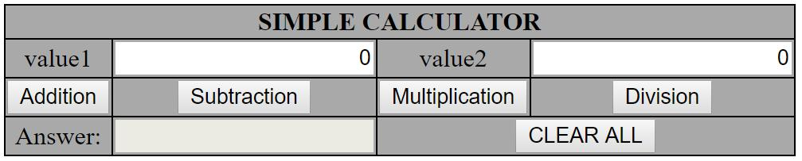

Department of CS&E Page 14

|  |  |
| --- | --- |
| Web Technology Laboratory With Mini Project | 17CSL77 |
|  |  |

Program 2

Write a JavaScript that calculates the squares and cubes of the numbers from 0 to 10and outputs HTML text that displays the resulting values in an HTML table format.

**2.1 CODE:**

<!DOCTYPE HTML>

<html>

<head>

<style>

table,tr, td

{

border: solid black;

width: 33%;

text-align: center;

border-collapse: collapse;

background-color:lightblue;

}

table { margin: auto; }

</style>

<script>

document.write( "<table> <tr><th colspan='3'> NUMBERS FROM 0 TO 10 WITH THEIR SQUARES AND CUBES </th></tr>" );

document.write( "<tr> <td>Number</td> <td>Square</td> <td>Cube</td>

</tr>" );

for(var n=0; n<=10; n++)

{



Department of CS&E Page 15

|  |  |
| --- | --- |
| Web Technology Laboratory With Mini Project | 17CSL77 |
|  |  |

document.write( "<tr><td>" + n + "</td><td>" + n*n + "</td><td>" +

n*n*n + "</td></tr>" ) ;

}

document.write( "</table>" ) ;

</script>

</head>

</html>

**2.2 Sample Output:**

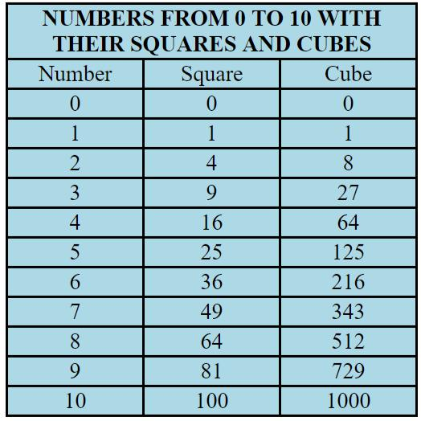

Department of CS&E Page 16

|  |  |
| --- | --- |
| Web Technology Laboratory With Mini Project | 17CSL77 |
|  |  |

Program 3

Write a JavaScript code that displays text “TEXT-GROWING” with increasing font size in the interval of 100ms in RED COLOR, when the font size reaches 50pt it displays “TEXT-SHRINKING” in BLUE color. Then the font size decreases to 5pt.

**3.1 CODE:**

<!DOCTYPE HTML>

<html>

<head>

<style>

p {

position: absolute;

top: 50%;

left: 50%;

transform: translate(-50%, -50%);

}

</style>

</head>

<body>

<p id="demo"></p>

<script>

var var1 = setInterval(inTimer, 1000);

var fs = 5;

var ids = document.getElementById("demo");

function inTimer() {

ids.innerHTML = 'TEXT GROWING'; ids.setAttribute('style', "font-size: " + fs + "px; color: red");



Department of CS&E Page 17

|  |  |
| --- | --- |
| Web Technology Laboratory With Mini Project | 17CSL77 |
|  |  |

fs += 5;

if(fs >= 50 ){

clearInterval(var1);

var2 = setInterval(deTimer, 1000);

}

}

function deTimer() {

fs -= 5;

ids.innerHTML = 'TEXT SHRINKING'; ids.setAttribute('style', "font-size: " + fs + "px; color: blue"); if(fs === 5 ){

clearInterval(var2);

}

}

</script>

</body>

</html>

**3.2 Sample Output:**

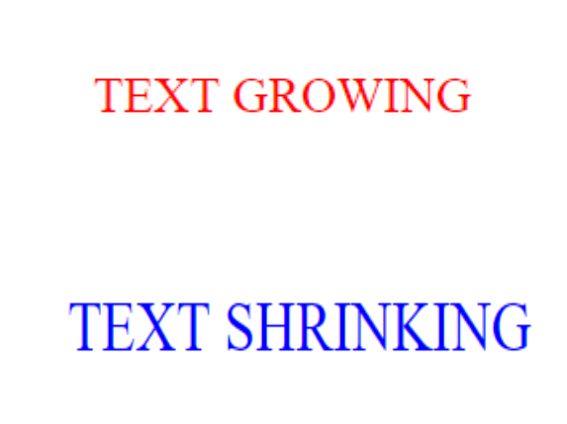

Department of CS&E Page 18

|  |  |
| --- | --- |
| Web Technology Laboratory With Mini Project | 17CSL77 |
|  |  |

Program 4

Develop and demonstrate a HTML5 file that includes JavaScript script that uses functions for the following problems:

1. Parameter: A string
2. Output: The position in the string of the left-most vowel
3. Parameter: A number
4. Output: The number with its digits in the reverse order

**4.1 CODE:**

<!DOCTYPE HTML>

<html>

<body>

<script type="text/javascript">

var str = prompt("Enter the Input","");

if(!(isNaN(str)))

{

var num,rev=0,remainder;

num = parseInt(str);

while(num!=0) {

remainder = num%10;

num = parseInt(num/10);

rev = rev * 10 + remainder;

}

alert("Reverse of "+str+" is "+rev);



Department of CS&E Page 19

|  |  |
| --- | --- |
| Web Technology Laboratory With Mini Project | 17CSL77 |
|  |  |

}

else

{

str = str.toUpperCase();

for(var i = 0; i < str.length; i++) {

var chr = str.charAt(i);

if(chr == 'A' || chr == 'E' || chr == 'I' || chr == 'O' || chr == 'U')break;

}

if( i < str.length )

alert("The position of the left most vowel is "+(i+1));

else

alert("No vowel found in the entered string");

}

</script>

</body>

</html>

**4.2 Sample Output:**

Enter the Input: GOUTAM

The position of the left most vowel is 2

Input Number : 567

Reverse of 567 is 765



Department of CS&E Page 20

|  |  |
| --- | --- |
| Web Technology Laboratory With Mini Project | 17CSL77 |
|  |  |

Program 5

Design an XML document to store information about a student in an engineering college affiliated to VTU. The information must include USN, Name, and Name of the College, Branch, Year of Joining, and email id. Make up sample data for 3students. Create a CSS style sheet and use it to display the document.

**5.1 CODE:**

**5.css**

student

{

display:block; margin-top:10px; color:Navy;

}

USN

{

display:block; margin-left:10px;font-size:14pt; color:Red;

}

name

{

display:block; margin-left:20px;font-size:14pt; color:Blue;

}

college

{

display:block; margin-left:20px;font-size:12pt; color:Maroon;

}

branch

{

display:block; margin-left:20px;font-size:12pt; color:Purple;

}



Department of CS&E Page 21

|  |  |
| --- | --- |
| Web Technology Laboratory With Mini Project | 17CSL77 |
|  |  |

year

{

display:block; margin-left:20px;font-size:14pt; color:Green;

}

e-mail

{

display:block; margin-left:20px;font-size:12pt; color:Blue;

}

**5.xml**

<?xml-stylesheet type="text/css" href="5.css" ?>

<!DOCTYPE HTML>

<html>

<head>

<h1> STUDENTS DESCRIPTION </h1>

</head>

<students>

<student>

<USN>USN : 1RN07CS001</USN>

<name>NAME : SANTHOSH</name>

<college>COLLEGE: RNSIT</college>

<branch>BRANCH : Computer Science and Engineering</branch>

|  |  |  |
| --- | --- | --- |
| <year>YEAR | : | 2007</year> |
| <e-mail>E-Mail : | | santosh@gmail.com</e-mail> |
| </student> |  |  |
| <student> |  |  |
| <USN>USN | : 1RN07IS001</USN> | |
|  |  |  |
|  |  |  |
| Department of CS&E |  | Page 22 |

|  |  |
| --- | --- |
| Web Technology Laboratory With Mini Project | 17CSL77 |
|  |  |

<name>NAME : MANORANJAN</name>

<college>COLLEGE: RNSIT</college>

<branch>BRANCH : Information Science and Engineering</branch>

<year>YEAR : 2007</year>

<e-mail>E-Mail : manoranjan@gmail.com</e-mail>

</student>

<student>

<USN>USN : 1RN07EC001</USN>

<name>NAME : CHETHAN</name>

<college>COLLEGE: RNSIT</college>

<branch>BRANCH : Electronics and Communication Engineering</branch>

<year>YEAR : 2007</year>

<e-mail>E-Mail : chethan@gmail.com</e-mail>

</student>

</students>

</html>



Department of CS&E Page 23

|  |  |
| --- | --- |
| Web Technology Laboratory With Mini Project | 17CSL77 |
|  |  |

**5.2 Sample Output:**

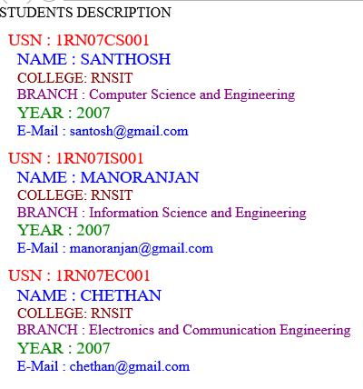

Department of CS&E Page 24

|  |  |
| --- | --- |
| Web Technology Laboratory With Mini Project | 17CSL77 |
|  |  |

Program 6

Write a PHP program to keep track of the number of visitors visiting the web page and to display this count of visitors, with proper headings.

**6.1 CODE:**

<?php

print "<h3> REFRESH PAGE </h3>";

$fname="counter.txt";

$fp = fopen($fname,"r");

$hits= fscanf($fp,"%d");

fclose($fp);

$hits[0]++;

$fp = fopen($fname,"w");

fprintf($fp,"%d",$hits[0]);

fclose($fp);

print "Total number of views: ".$hits[0];

?>

**6.2 Sample Output:**

**REFRESH PAGE**

Total number of views: 2



Department of CS&E Page 25

|  |  |
| --- | --- |
| Web Technology Laboratory With Mini Project | 17CSL77 |
|  |  |

Program 7

Write a PHP program to display a digital clock which displays the current time of the server.

**7.1 CODE:**

<!DOCTYPE HTML>

<html>

<head>

<meta http-equiv="refresh" content="1"/>

<style>

p {

color:white;

font-size:90px;

position: absolute;

top: 50%;

left: 50%;

transform: translate(-50%, -50%);

}

body{background-color:black;}

</style>

<p> <?php echo date(" h: i : s A");?> </p>

</head>

</html>



Department of CS&E Page 26

|  |  |
| --- | --- |
| Web Technology Laboratory With Mini Project | 17CSL77 |
|  |  |

**7.2 Sample Output:**

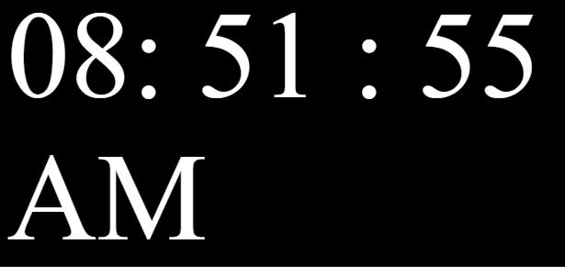

Department of CS&E Page 27

|  |  |
| --- | --- |
| Web Technology Laboratory With Mini Project | 17CSL77 |
|  |  |

Program 8

Write the PHP programs to do the following:

1. Implement simple calculator operations.
2. Find the transpose of a matrix.
3. Multiplication of two matrices.
4. Addition of two matrices.

**8.1 CODE:**

**8a.php**

<!DOCTYPE HTML>

<html>

<head>

<style>

table, td, th

{

border: 1px solid black;

width: 33%;

text-align: center;

background-color: DarkGray;

}

table { margin: auto; }

input,p { text-align:right; }

</style>

</head>

<body>

<form method="post">

<table>



Department of CS&E Page 28

|  |  |
| --- | --- |
| Web Technology Laboratory With Mini Project | 17CSL77 |
|  |  |

<caption><h2> SIMPLE CALCULATOR </h2></caption> <tr><td>Value 1:</td><td><input type="text" name="num1"/></td>

<td rowspan="2"><input type="submit" name="submit" value="calculate"> </td></tr> <tr><td>Value 2:</td><td> <input type="text" name="num2"/> </td> </tr>

</form>

<?php

if(isset($_POST['submit'])) // it checks if the input submit is filled

{

$num1 = $_POST['num1'];

$num2 = $_POST['num2'];

if(is_numeric($num1) and is_numeric($num2)) {

echo "<tr><td colspan='2'> Addition :</td><td><p>".($num1+$num2)."</p></td></tr>"; echo "<tr><td colspan='2'> Subtraction :</td><td><p>".($num1-$num2)."</p></td></tr>";

echo "<tr><td colspan='2'> Multiplication :</td><td><p>".($num1*$num2)."</p></td></tr>";

echo "<tr><td colspan='2'> Division :</td><td><p>".($num1/$num2)."</p></td></tr>"; echo "</table>";

}

else{

echo "<script type='text/javascript'>alert(' ENTER VALID NUMBERS');</script>";

}

}

?>

</html>



Department of CS&E Page 29

|  |  |
| --- | --- |
| Web Technology Laboratory With Mini Project | 17CSL77 |
|  |  |

**8a.2 Sample Output:**

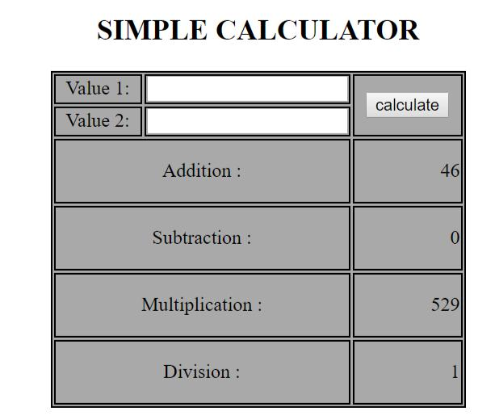

**8b.php**

<?php

$a = array(array(1,2,3),array(4,5,6),array(7,8,9));

$b = array(array(7,8,9),array(4,5,6),array(1,2,3));

$m=count($a);

$n=count($a[2]);

$p=count($b);

$q=count($b[2]);

echo "the first matrix :"."<br/>";

for ($row = 0; $row < $m; $row++) {

for ($col = 0; $col < $n; $col++)

echo " ".$a[$row][$col];

echo "<br/>";

}

echo "the second matrix :"."<br/>";

for ($row = 0; $row < $p; $row++) {



Department of CS&E Page 30

|  |  |
| --- | --- |
| Web Technology Laboratory With Mini Project | 17CSL77 |
|  |  |

for ($col = 0; $col < $q; $col++)

echo " ".$b[$row][$col];

echo "<br/>";

}

echo "the transpose for the first matrix is:"."<br/>";

for ($row = 0; $row < $m; $row++) {

for ($col = 0; $col < $n; $col++)

echo " ".$a[$col][$row];

echo "<br/>";

}

if(($m===$p) and ($n===$q)) {

echo "the addition of matrices is:"."<br/>";

for ($row = 0; $row < 3; $row++) {

for ($col = 0; $col < 3; $col++)

echo " ".$a[$row][$col]+$b[$row][$col]." ";

echo "<br/>";

}

}

if($n===$p){

echo " The multiplication of matrices: <br/>";

$result=array();

for ($i=0; $i < $m; $i++) {

for($j=0; $j < $q; $j++){

$result[$i][$j] = 0;

for($k=0; $k < $n; $k++)

$result[$i][$j] += $a[$i][$k] * $b[$k][$j];



Department of CS&E Page 31

|  |  |
| --- | --- |
| Web Technology Laboratory With Mini Project | 17CSL77 |
|  |  |

}

}

for ($row = 0; $row < $m; $row++) {

for ($col = 0; $col < $q; $col++)

echo " ".$result[$row][$col];

echo "<br/>";

}

}

?>

**8b.2 Sample Output:**

the first matrix :

1 2 3

4 5 6

7 8 9

the second matrix :

7 8 9

4 5 6

1 2 3

the transpose for the first matrix is:

1 4 7

2 5 8

3 6 9

the addition of matrices is:

81012

81012

81012

The multiplication of matrices:

18 24 30

54 69 84

90 114 138



Department of CS&E Page 32

|  |  |
| --- | --- |
| Web Technology Laboratory With Mini Project | 17CSL77 |
|  |  |

Program 9

Write a PHP program named states.py that declares a variable states with value “Mississippi

Alabama Texas Massachusetts Kansas". write a PHP program that does the following:

1. Search for a word in variable states that ends in xas. Store this word in element0 of a list named states List.
2. Search for a word in states that begins with k and ends in s. Perform a case-insensitive comparison. [Note: Passing re.Ias a second parameter to method compile performs a case-insensitive comparison.] Store this word in element1of states List.
3. Search for a word in states that begins with M and ends in s. Store this word in element 2 of the list.
4. Search for a word in states that ends in a. Store this word in element 3 of the list.

**9.1 CODE:**

<?php

$states = "Mississippi Alabama Texas Massachusetts Kansas"; $statesArray = [];

$states1 = explode(' ',$states);

echo "Original Array :<br>";

foreach ( $states1 as $i => $value ){

print("STATES[$i]=$value<br>");

}

foreach($states1 as $state) {

if(preg_match( '/xas$/', ($state)))

$statesArray[0] = ($state);

}

foreach($states1 as $state) {

if(preg_match('/^k.*s$/i', ($state)))

$statesArray[1] = ($state);



Department of CS&E Page 33

|  |  |
| --- | --- |
| Web Technology Laboratory With Mini Project | 17CSL77 |
|  |  |

}

foreach($states1 as $state) {

if(preg_match('/^M.*s$/', ($state)))

$statesArray[2] = ($state);

}

foreach($states1 as $state) {

if(preg_match('/a$/', ($state)))

$statesArray[3] = ($state);

}

echo "<br><br>Resultant Array :<br>";

foreach ( $statesArray as $array => $value ){

print("STATES[$array]=$value<br>");

}

?>

**9.2 Sample Output:**

Original Array :

STATES[0]=Mississippi

STATES[1]=Alabama

STATES[2]=Texas

STATES[3]=Massachusetts

STATES[4]=Kansas

Resultant Array :

STATES[0]=Texas

STATES[1]=Kansas

STATES[2]=Massachusetts

STATES[3]=Alabama



Department of CS&E Page 34

|  |  |
| --- | --- |
| Web Technology Laboratory With Mini Project | 17CSL77 |
|  |  |

Program 10

Write a PHP program to sort the student records which are stored in the database using selection sort.

**10.1 CODE:**

<!DOCTYPE HTML>

<html>

<body>

<style>

table, td, th

{

border: 1px solid black;

width: 33%;

text-align: left;

border-collapse:collapse;

background-color:lightblue;

}

table { margin: auto; }

</style>

<?php

$servername = "localhost";

$username = "root";

$password = "root";

$dbname = "weblab";

$a=[];

// Create connection



Department of CS&E Page 35

|  |  |
| --- | --- |
| Web Technology Laboratory With Mini Project | 17CSL77 |
|  |  |

$conn = mysqli_connect($servername, $username, $password, $dbname); //The MySQLi functions allows you to access MySQL database servers.

// Check connection

if ($conn->connect_error) {

die("Connection failed: " . $conn->connect_error);

}

$sql = "SELECT * FROM student";

$result = $conn->query($sql); // performs a query against the database

echo "<br>";

echo "<center> BEFORE SORTING </center>";

echo "<table border='2'>";

echo "<tr>";

echo "<th>USN</th><th>NAME</th><th>Address</th> </tr>";

if ($result->num_rows > 0)

{

// output data of each row

while($row = $result->fetch_assoc()) // fetches a result row as an associative array

{

echo "<tr>";

echo "<td>". $row["usn"]."</td>";

echo "<td>". $row["name"]."</td>";

echo "<td>". $row["addr"]."</td></tr>";

array_push($a,$row["usn"]);

}

}



Department of CS&E Page 36

|  |  |
| --- | --- |
| Web Technology Laboratory With Mini Project | 17CSL77 |
|  |  |

else {

echo "Table is Empty";

}

echo "</table>";

$n=count($a);

$b=$a;

for ( $i = 0 ; $i < ($n - 1) ; $i++ )

{

$pos= $i;

for ( $j = $i + 1 ; $j < $n ; $j++ )

{

if ( $a[$pos] > $a[$j] )

$pos= $j;

}

if ( $pos!= $i )

{

$temp=$a[$i];

$a[$i] = $a[$pos];

$a[$pos] = $temp;

}

}

$c=[];



Department of CS&E Page 37

|  |  |
| --- | --- |
| Web Technology Laboratory With Mini Project | 17CSL77 |
|  |  |

$d=[];

$result = $conn->query($sql);

if ($result->num_rows > 0) {

// output data of each row

while($row = $result->fetch_assoc()) {

for($i=0;$i<$n;$i++){

if($row["usn"]== $a[$i]){

$c[$i]=$row["name"];

$d[$i]=$row["addr"];

}

}

}

}

echo "<br>";

echo "<center> AFTER SORTING <center>";

echo "<table border='2'>";

echo "<tr>";

echo "<th>USN</th><th>NAME</th><th>Address</th> </tr>"; for($i=0;$i<$n;$i++){

echo "<tr>";

echo "<td>". $a[$i]."</td>";

echo "<td>". $c[$i]."</td>";

echo "<td>". $d[$i]."</td></tr>";

}

echo "</table>";

$conn->close();



Department of CS&E Page 38

|  |  |
| --- | --- |
| Web Technology Laboratory With Mini Project | 17CSL77 |
|  |  |

?>

</body>

</html>

**10.2 Sample Output:**

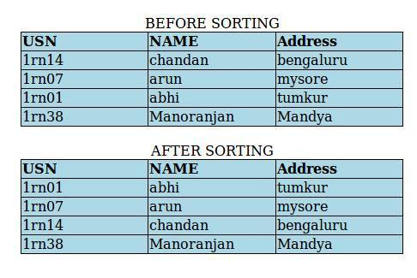

Department of CS&E Page 39

**Viva Questions**

**What is HTML?**Answer1:  
HTML, or HyperText Markup Language, is a Universal language which allows an individual using special code to create web pages to be viewed on the Internet.  
**What is a tag?**   
In HTML, a tag tells the browser what to do. When we write an HTML page, we enter tags for many reasons -- to change the appearance of text, to show a graphic, or to make a link to another page.

**What is the simplest HTML page?**   
HTML Code:  
<HTML>  
<HEAD>  
<TITLE>**This is my page title!** </TITLE>  
</HEAD>  
<BODY>  
 **this is my message to the world!**</BODY>  
</HTML>   
**How do I create frames? What is a frameset?**   
Frames allow an author to divide a browser window into multiple (rectangular) regions. Multiple documents can be displayed in a single window, each within its own frame. Graphical browsers allow these frames to be scrolled independently of each other, and links can update the document displayed in one frame without affecting the others.   
You can't just "add frames" to an existing document. Rather, you must create a frameset document that defines a particular combination of frames, and then display your content documents inside those frames. The frameset document should also include alternative non-framed content in a NOFRAMES element.   
The HTML 4 frames model has significant design flaws that cause usability problems for web users. Frames should be used only with great care.

**How can I include comments in HTML?**   
Technically, since HTML is an SGML application, HTML uses SGML comment syntax. However, the full syntax is complex, and browsers don't support it in its entirety anyway. Therefore, use the following simplified rule to create HTML comments that both have valid syntax and work in browsers:  
An HTML comment begins with "<!--", ends with "-->", and does not contain "--" or ">" anywhere in the comment.   
The following are examples of HTML comments:  
* <!-- This is a comment. -->  
* <!-- This is another comment,  
and it continues onto a second line. -->  
* <!---->  
**What is a Hypertext link?**   
A hypertext link is a special tag that links one page to another page or resource. If you click the link, the browser jumps to the link's destination.

**What is a DOCTYPE? Which one do I use?**   
According to HTML standards, each HTML document begins with a DOCTYPE declaration that specifies which version of HTML the document uses. Originally, the DOCTYPE declaration was used only by SGML-based tools like HTML validators, which needed to determine which version of HTML a document used (or claimed to use).   
Today, many browsers use the document's DOCTYPE declaration to determine whether to use a stricter, more standards-oriented layout mode, or to use a "quirks" layout mode that attempts to emulate older, buggy browsers.

**How do I align a table to the right (or left)?**You can use <TABLE ALIGN="right"> to float a table to the right. (Use ALIGN="left" to float it to the left.) Any content that follows the closing </TABLE> tag will flow around the table. Use <BR CLEAR="right"> or <BR CLEAR="all"> to mark the end of the text that is to flow around the table, as shown in this example:  
The table in this example will float to the right.  
<table align="right">...</table>  
This text will wrap to fill the available space to the left of (and if the text is long enough, below) the table.  
<br clear="right">  
This text will appear below the table, even if there is additional room to its left.

### Explain Cell Padding and Cell Spacing.

Cell Padding: it refers to the gap or space between the cell content and cell border or cell wall.  
Cell Spacing: It refers to the gap between the two cells of same tables.  
In HTML cell spacing and padding both are used with Table Border layout.  
Example:   
<table border cellpadding=2>  
<table border cellspacing=2>  
<table border cellpadding=2 cellspacing=2>

### How to create a button which acts like a link?

To create buttons which act as a hyperlink, there are two ways:

<FORM ACTION="[url]" METHOD=get>  
<INPUT TYPE=submit VALUE="Text on button">  
</FORM>

<INPUT TYPE="submit" VALUE="Go to my link location"   
ONCLICK=" http://www.careerride.com/;" />

### What is difference between HTML and XHTML?

The differences between HTML and XHTML are:

HTML is application of Standard Generalized Markup Language(SGML) whereas XML is application of Extensible Markup Language(XML).

HTML is a static Web Page whereas XHTML is dynamic Web Page.

HTML allows programmer to perform changes in the tags and use attribute minimization whereas XHTML when user need a new markup tag then user can define it in this.

HTML is about displaying information whereas XHTML is about describing the information

**How many types CSS can be include in HTML?**

There are three ways to include the CSS with HTML:

**Inline CSS:** it is used when only small context is to be styled.  
o To use inline styles add the style attribute in the relevant tag.

**External Style Sheet:** is used when the style is applied to many pages.  
o Each page must link to the style sheet using the <link> tag. The <link> tag goes inside the head section:   
<head>   
<link rel="stylesheet" type="text/css" href="mystyle.css" />   
</head>

**Internal Style Sheet:** is used when a single document has a unique style.  
o Internal styles sheet needs to put in the head section of an HTML page, by using the <style> tag, like this:   
<head>   
<style type="text/css">   
hr {color:sienna}   
p {margin-left:20px}   
body {background-image:url("images/back40.gif")}   
</style>   
</head>

**What are logical and physical tags in HTML?**

Logical tags are used to tell the meaning of the enclosed text. The example of the logical tag is <strong> </strong> tag. When we enclosed text in strong tag then it tell the browser that enclosed text is more important than other text.  
Physical text are used to tell the browser that how to display the text enclosed in the physical tag.   
Some example of the physical tags are: <b> , <big> , <i>

**Does HTML support Javascripts?**

Yes, HTML supports JavaScripts. We can use JavaScript anywhere in the HTML Coding. Mainly there are four sections where we can add JavaScript in HTML.

**Head Section:** we can add JavaScript in Head section of HTML.  
<head>…..Javascript…. </head>

**Body Section:** <body>….. Javascript…</body>

**Head and Body both:** we can add Javascript in both head and body section.  
<body….Javascript…</body> and <head>…..Javascript…. </head>

**External File:** script in and external file and then include in <head> ….. </head> section.

**Explain marquee tag.**

Marquee tag: Marquee tag is used when we want that some text or content move in the web page whether horizontally or vertically.   
Syntax of Marquee tag: <marquee>move text</marquee>  
Attribute of Marquee tag are: bgcolor, direction, height, width, vspace etc.

**How do I add midi music to my web page?**

We can add midi Music in our HTML web page using following tag:  
<bgsound src="music.mid" loop="1">  
Attribute LOOP= 1: shows that music.mid is played only for one time. We can also set the value of loop to infinite. This tag is supported by Netscape and Internet Explorer.  
Example: <embed src="canyon.mid" Autostart=TRUE Width=145 Height=60 Loop=true>

**What are new Media Elements in HTML5?**

Following are the New Media Elements are present in HTML5:

**<audio> tag:** for playing audio.

**<video> tag:** for playing video.

**<source> tag:** For media resources for media elements.

**<embed> tag:** For embedded content,

**<track> tag:** For text tracks used in media players

**Explain various HTML list tags.**

In HTML we can list the element in two ways:

**Ordered list:** in this list item are marked with numbers.  
Syntax: <ol>  
<li> first item </li>  
<li>second item </li> </ol>  
Display as: 1. First item  
2. Second item.

**Unordered Lists:** in this item are marked with bullets.  
Syntax: <ul>  
<li> first item </li>  
<li>second item </li> </ul>  
Display as:   
-First item  
-Second item.

**Explain HTML background.**

There are two types of background in HTML:

**Colored Background:** in this the background of the html is colored.   
The Syntax is: <body bgcolor = “red”>  
The value of the bgcolor can be set in three ways by hexadecimal number, an RGB value and Color name.  
Example: <body bgcolor = “black”>  
<body bgcolor = “rgb(0,0,0)”>  
<body bgcolor = “#000000”>

**Image Background:** in this we set the background of the website by an image. Syntax used for this is : <body background=”study.gif”>

**What is CSS?**

CSS stands for Cascading Style Sheets. By using CSS with HTML we can change the look of the web page by changing the font size and color of the font. CSS plays an important role in building the website. Well written CSS file can be used to change the presentation of each web page. By including only one CSS file. It gives web site developer and user more control over the web pages.

**How to insert Javascript in HTML?**

We can insert JavaScript in HTML using <Script tag>. JavaScript can be enclosed in <script type = text/javascript> and ending with </script>.  
**Example:**<html>   
  <body>   
        <script type="text/javascript">   
               ...JavaScript….  
         </script>   
   </body>   
</html>

**What is the Use of SPAN in HTML and give one example?**

SPAN: Used for the following things:

Highlight the any color text

For adding colored text

For adding background image to text.

Example:

<p>  
<span style="color:#000000;">  
In this page we use span.  
</span>  
</p>

**What are style sheet properties?**

CSS Background  
CSS Text  
CSS Font  
CSS Border  
CSS Outline  
CSS Margin  
CSS Padding  
CSS List  
CSS Table

**List various font attributes used in style sheet.**

font-style  
font-variant  
font-weight  
font-size/line-height  
font-family  
caption  
icon  
menu  
message-box  
small-caption  
status-bar

**Explain inline, embedded and external style sheets.**

**Inline**If only a small piece of code has to be styled then inline style sheets can be used.

**Embedded**Embedded style sheets are put between the <head> </head> tags.

**External**If you want to apply a style to all the pages within your website by changing just one style sheet, then external style sheets can be used.

**How do I create a link that opens a new window?**<a target="_blank" href=...> opens a new, unnamed window.  
<a target="example" href=...> opens a new window named "example", provided that a window or frame by that name does not already exist.  
Note that the TARGET attribute is not part of HTML 4 Strict. In HTML 4 Strict, new windows can be created only with JavaScript. links that open new windows can be annoying to your readers if there is not a good reason for them.

**What is the difference between the HTML form methods GET and POST?**The method parameter specifies which method the client is using to send information to the WEB server. The method determines which parameter you will find the CGI request data in:  
* **POST** - post_args  
* **GET** - httpargs

#### What is the DOM?

DOM is a platform independent, World Wide Web Consortium (W3C) standard form of representation of structured documents as an object-oriented model. It is an application programming interface so as to access HTML and XML documents.

Document Object Model (DOM) is used to query, traverse and manipulate documents like XML or HTML documents. DOM is best suited where the document must be accessed repeatedly or out of sequence order. DOM allows accessing the contents of a web page. It also allows dealing with events that allows capturing and responding to user’s actions. There are different levels of DOM standards depending on the compatibility of the browsers.

#### What is the HTML DOM?

The HTML DOM API specializes and adds the functionality to relate to HTML documents and elements. It addresses the issues of backwards compatibility with the Level 0 of DOM and provides mechanisms for common and frequent operations on HTML documents

#### What is JavaScript?

JavaScript is a platform-independent,event-driven, interpreted client-side scripting language developed by Netscape Communications Corp. and Sun Microsystems.

JavaScript is a general-purpose programming language designed to let programmers of all skill levels control the behavior of software objects. The language is used most widely today in Web browsers whose software objects tend to represent a variety of HTML elements in a document and the document itself.

But the language is used with other kinds of objects in other environments. For example, Adobe Acrobat Forms uses JavaScript as its underlying scripting language to glue together objects that are unique to the forms generated by Adobe Acrobat.

Therefore, it is important to distinguish JavaScript, the language, from the objects it can communicate with in any particular environment.

When used for Web documents, the scripts go directly inside the HTML documents and are downloaded to the browser with the rest of the HTML tags and content.

#### How is JavaScript different from Java?

Don't be fooled by the term Java in both. Both are quite different technologies.

JavaScript was developed by Brendan Eich of Netscape; Java was developed at Sun Microsystems. While the two languages share some common syntax, they were developed independently of each other and for different audiences. Java is a full-fledged programming language tailored for network computing; it includes hundreds of its own objects, including objects for creating user interfaces that appear in Java applets (in Web browsers) or standalone Java applications. In contrast, JavaScript relies on whatever environment it's operating in for the user interface, such as a Web document's form elements.

JavaScript was initially called LiveScript at Netscape while it was under development. A licensing deal between Netscape and Sun at the last minute let Netscape plug the "Java" name into the name of its scripting language. Programmers use entirely different tools for Java and JavaScript. It is also not uncommon for a programmer of one language to be ignorant of the other. The two languages don't rely on each other and are intended for different purposes. In some ways, the "Java" name on JavaScript has confused the world's understanding of the differences between the two. On the other hand, JavaScript is much easier to learn than Java and can offer a gentle introduction for newcomers who want to graduate to Java and the kinds of applications you can develop with it.

#### What is the official JavaScript website?

This is a trick question used by interviewers to evaluate the candidate’s knowledge of JavaScript. Most people will simply say javascript.com is the official website.

The truth is- there is no official website for Javascript you can refer to. It was developed by Brendan Eich for Netscape. It was based on the ECMAScript language standard; ECMA-262 being the official JavaScript standard.

**What are JavaScript types?**Number, String, Boolean, Function, Object, Null, Undefined.  
**How do you convert numbers between different bases in JavaScript?**Use the parseInt() function, that takes a string as the first parameter, and the base as a second parameter. So to convert hexadecimal 3F to decimal, use parseInt ("3F", 16);  
**What does "1"+2+3 evaluate to?**Since 1 is a string, everything is a string, so the result is 123.  
**How about 3+5+"8"?**Since 3 and 5 are integers, this is number arithmetic, since 8 is a string, it’s concatenation, so 88 is the result.  
**How do you submit a form using Javascript?**Use document.forms[0].submit();  
**How do you assign object properties?**obj["age"] = 22 or obj.age = 22.  
**What’s a way to append a value to an array?**arr[arr.length] = value;  
**What does isNaN function do?**Return true if the argument is not a number.  
**What’s relationship between JavaScript and ECMAScript?**ECMAScript is yet another name for JavaScript (other names include LiveScript). The current JavaScript that you see supported in browsers is ECMAScript revision 3.  
**How to read and write a file using javascript?**I/O operations like reading or writing a file is not possible with client-side javascript.  
**How do you convert numbers between different bases in JavaScript?**Use the parseInt() function, that takes a string as the first parameter, and the base as a second parameter. So to convert hexadecimal FF to decimal, use parseInt ("FF", 16);  
**What is negative infinity?**It’s a number in JavaScript, derived by dividing negative number by zero.  
**How to set a HTML document's background color?**document.bgcolor property can be set to any appropriate color.  
**What boolean operators does JavaScript support?**&&, and !  
**How to get the contents of an input box using Javascript?**Use the "value" property.  
var myValue = window.document.getElementById("textboxID").value;  
**How to determine the state of a checkbox using Javascript?**var checkedP = window.document.getElementById("CheckBoxID").checked;  
**How to set the focus in an element using Javascript?**<script> function setFocus() { if(focusElement != null) { document.forms[0].elements["myelementname"].focus(); } } </script>  
**How to access an external javascript file that is stored externally and not embedded?**This can be achieved by using the following tag between head tags or between body tags.  
<script src="raj.js"></script>How to access an external javascript file that is stored externally and not embedded? where abc.js is the external javscript file to be accessed.  
**What is the difference between an** alert **box and a confirmation box?**An alert box displays only one button which is the OK button whereas the Confirm box displays two buttons namely OK and cancel.  
**What is a prompt box?**A prompt box allows the user to enter input by providing a text box.  
**Can javascript code be broken in different lines?**Breaking is possible within a string statement by using a backslash \ at the end but not within any other javascript statement.  
that is ,  
document.write("Hello \ world");  
is possible but not document.write \  
("hello world");  
**What looping structures are there in JavaScript?**for, while, do-while loops, but no foreach.  
**How do you create a new object in JavaScript?**var obj = new Object(); or var obj = {};  
**What is this keyword?**It refers to the current object.  
**What is the difference between SessionState and ViewState?**ViewState is specific to a page in a session. Session state refers to user specific data that can be accessed across all pages in the web application.  
**What looping structures are there in JavaScript?**for, while, do-while loops, but no foreach.  
**To put a "close window" link on a page ?**<a href='javascript:window.close()' class='mainnav'> Close </a>  
**How to hide javascript code from old browsers that dont run it?**Use the below specified style of comments <script language=javascript> <!-- javascript code goes here // --> or Use the <NOSCRIPT>some html code </NOSCRIPT> tags and code the display html statements between these and this will appear on the page if the browser does not support javascript  
**How to comment javascript code?**Use // for line comments and  
/*  
*/ for block comments  
**Name the numeric constants representing max,min values**Number.MAX_VALUE  
Number.MIN_VALUE  
**What does javascript null mean?**The null value is a unique value representing no value or no object.  
It implies no object,or null string,no valid boolean value,no number and no array object.  
**How do you create a new object in JavaScript?**var obj = new Object(); or var obj = {};  
**How do you assign object properties?**obj["age"] = 23 or obj.age = 23.  
**What’s a way to append a value to an array?**arr[arr.length] = value;  
**To set all checkboxes to true using JavaScript?**//select all input tags  
function SelectAll() {  
var checkboxes = document.getElementsByTagName("input");  
for(i=0;i<checkboxes.length;i++) {  
if(checkboxes.item(i).attributes["type"].value == "checkbox") {  
checkboxes.item(i).checked = true;  
}  
}  
}  
**What does undefined value mean in javascript?**Undefined value means the variable used in the code doesn't exist or is not assigned any value or the property doesn't exist.  
**What is the difference between undefined value and null value?**(i)Undefined value cannot be explicitly stated that is there is no keyword called undefined whereas null value has keyword called null  
(ii)typeof undefined variable or property returns undefined whereas typeof null value returns object  
**What are undefined and undeclared variables?**Undeclared variables are those that are not declared in the program (do not exist at all),trying to read their values gives runtime error.But if undeclared variables are assigned then implicit declaration is done .  
Undefined variables are those that are not assigned any value but are declared in the program.Trying to read such variables gives special value called undefined value.  
**What is === operator ?**==== is strict equality operator ,it returns true only when the two operands are having the same value without any type conversion.  
**How to disable an HTML object ?**document.getElementById("myObject").disabled = true;  
**How to create a popup warning box?**alert('Warning: Please enter an integer between 0 and 1000.');  
**How to create a confirmation box?**confirm("Do you really want to launch the missile?");  
**How to create an input box?**prompt("What is your temperature?");  
**How to force a page to go to another page using JavaScript ?**<script language="JavaScript" type="text/javascript" ><!-- location.href="http://rajeshstutorials.blogspt.com"; //--></script>  
**What's Math Constants and Functions using JavaScript?**The Math object contains useful constants such as Math.PI, Math.E  
Math.abs(value); //absolute value  
Math.max(value1, value2); //find the largest  
Math.random() //generate a decimal number between 0 and 1  
Math.floor(Math.random()*101) //generate a decimal number between 0 and 100  
**How to get value from a textbox?**alert(document.getElementById('txtbox1').value);  
**How to get value from dropdown (select) control?**alert(document.getElementById('dropdown1').value);

## What is event bubbling?

Event bubbling describes the behavior of events in child and parent nodes in the Document Object Model (DOM); that is, all child node events are automatically passed to its parent nodes. The benefit of this method is speed, because the code only needs to traverse the DOM tree once. This is useful when you want to place more than one event listener on a DOM element since you can put just one listener on all of the elements, thus code simplicity and reduction. One application of this is the creation of one event listener on a page’s body element to respond to any click event that occurs within the page’s body.

**What is XML?**XML is the Extensible Markup Language. It improves the functionality of the Web by letting you identify your information in a more accurate, flexible, and adaptable way.   
It is extensible because it is not a fixed format like HTML (which is a single, predefined markup language). Instead, XML is actually a metalanguage—a language for describing other languages—which lets you design your own markup languages for limitless different types of documents. XML can do this because it's written in SGML, the international standard metalanguage for text document markup (ISO 8879).

**What is a markup language?**A markup language is a set of words and symbols for describing the identity of pieces of a document (for example ‘this is a paragraph’, ‘this is a heading’, ‘this is a list’, ‘this is the caption of this figure’, etc). Programs can use this with a style sheet to create output for screen, print, audio, video, Braille, etc.   
Some markup languages (e.g. those used in word processors) only describe appearances (‘this is italics’, ‘this is bold’), but this method can only be used for display, and is not normally re-usable for anything else.

**What is the difference between XML and HTML?**

XML is no way clashes with HTML, since they are for two different purposes.

|  |  |
| --- | --- |
| **HTML** | **XML** |
| HTML is for displaying purpose. | Whereas XML is for data representation. |
| HTML is used to mark up text so it can be displayed to users. | XML is used to mark up data so it can be processed by computers. |
| HTML describes both structure (e.g. <p>, <h2>, <em>) and appearance (e.g. <br>, <font>, <i>) | XML describes only content, or “meaning” |
| HTML uses a fixed, unchangeable set of tags | In XML, you make up your own tags |

**What are the benefits of XML?**

There are many benefits of using XML on the Web :

**Simplicity**- Information coded in XML is easy to read and understand, plus it can be processed easily by computers.

**Openness**- XML is a W3C standard, endorsed by software industry market leaders.

E**xtensibility** - There is no fixed set of tags. New tags can be created as they are needed.

**Self-description**- In traditional databases, data records require schemas set up by the database administrator. XML documents can be stored without such definitions, because they contain meta data in the form of tags and attributes.

**Contains machine-readable context information-** Tags, attributes and element structure provide context information that can be used to interpret the meaning of content, opening up new possibilities for highly efficient search engines, intelligent data mining, agents, etc.

**Separates content  from presentation**- XML tags describe meaning not presentation. The motto of HTML is: "I know how it looks", whereas the motto of XML is: "I know what it means, and you tell me how it should look." The look and feel of an XML document can be controlled by XSL style sheets, allowing the look of a document to be changed without touching the content of the document. Multiple views or presentations of the same content are easily rendered.

**Supports multilingual documents and Unicode**-This is important for the internationalization of applications.

**Facilitates the comparison and aggregation of data** - The tree structure of XML documents allows documents to be compared and aggregated efficiently element by element.

**Can embed multiple data types** - XML documents can contain any possible data type - from multimedia data (image, sound, video) to active components (Java applets, ActiveX).

**Can embed existing data** - Mapping existing data structures like file systems or relational databases to XML is simple. XML supports multiple data formats and can cover all existing data structures and .

**Provides a 'one-server view' for distributed data** - XML documents can consist of nested elements that are distributed over multiple remote servers. XML is currently the most sophisticated format for distributed data - the World Wide Web can be seen as one huge XML database.

#### What is XSL-FO?.

XSL-FO stands for Extensible Stylesheet Language Formatting Objects. It is used to format XML data and is also a W3C recommendation.

#### What is a well-formed XML document?

If a document is syntactically correct it can be called as well-formed XML documents. A well-formed document conforms to XML's basic rules of syntax:

Every open tag must be closed.

The open tag must exactly match the closing tag: XML is case-sensitive.

All elements must be embedded within a single root element.

Child tags must be closed before parent tags.

A well-formed document has correct XML tag syntax, but the elements might be invalid for the specified document type.

**What is a valid XML document?**

If a document is structurally correct then it can be called as valid XML documents. A valid document conforms to the predefined rules of a specific type of document:

These rules can be written by the author of the XML document or by someone else.

The rules determine the type of data that each part of a document can contain.

**Note**:*Valid XML document is implicitly well-formed, but well-formed may not be valid*

**What is the structure of XML document ?**

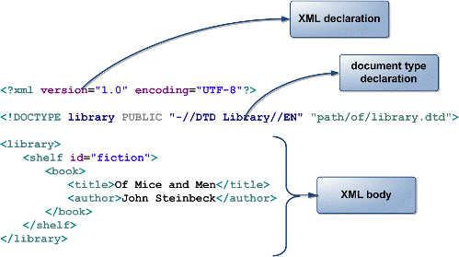

Figure 1: XML Structure

**What is a Processing Instruction in XML?**

A ProcessingIntruction is the information which we would like to give to application. Through a ProcessingInstruction an application would get idea about how to process the document. A ProcessingInstruction can appear anywhere and any no. of times in a document.

**How does the XML structure is defined?**

XML document will have a structure which has to be defined before we can create the documents and work with them. The structural rules can be defined using many available technologies, but the following are popular way of doing so-

Document Type Definition (DTD)

Schema

**What is DTD?**

A **Document Type Definition** (DTD) defines the legal building blocks of an XML document. It defines rules for a specific type of document, including:

Names of elements, and how and where they can be used

The order of elements

Proper nesting and containment of elements

Element attributes

To apply a DTD to an XML document, you can:

Include the DTD's element definitions within the XML document itself.

Provide the DTD as a separate file, whose name you reference in the XML document.

**What is XML Schema?**

An XML **Schema** describes the structure of an XML instance document by defining what each element must or may contain.XML Schema is expressed in the form of a separate XML file.

XML Schema provides much more control on element and attribute datatypes.

Some datatypes are predefined and new ones can be created.

<xsd:schema xmlns:xsd="http://www.w3.org/2001/XMLSchema">  
 <xsd:element name="test">  
 <xsd:complexType>

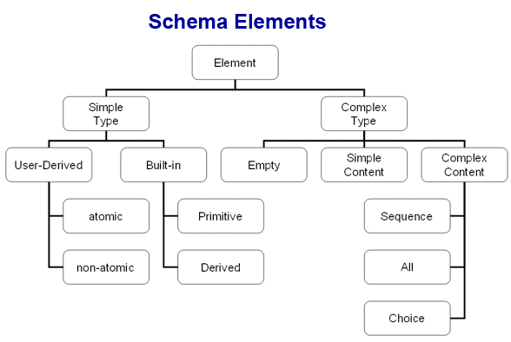

Figure 2: XML Schema

**What are differences between DTDs and Schema?**

|  |  |
| --- | --- |
| **Schema** | **DTD** |
| Schema document is an XML document i.e., the structure of an XML document is specified by another XML document. | DTDs follow SGML syntax. |
| Schema supports variety of dataTypes similar to programming language. | In DTD everything is treated as text. |
| In Schema,  It is possible to inherit and create relationship among elements. | This is not possible in DTD without invalidating existing documents. |
| In Schema, It is possible to group elements and attributes so that they can be treated as single logical unit. | Grouping of elements and attributes is not possible in DTD. |
| In Schemas, it is possible to specify an upper limit for the number of occurrences of an element | It is not possible to specify an upper limit of an element in DTDs |

**What is the version information in XML?**

"Version" tag shows which version of XML is used.

**If XML does not have closing tag will it work?**

No, every tag in XML, which is opened, should have a closing tag.

**Is XML case sensitive?**

Yes, XML is case sensitive.

**What is XML DOM?**

The DOM stands for Document Object Model, which describes the logical formation of documents and provides the way to access and manipulate a document. It supplies an Application Programming Interface (API) to XML documents. It is built around the object-oriented design; therefore, it is known as DOM. The DOM model considers an XML document as a composition of objects and every object consists of properties and behaviors that can be manipulated by the DOM methods. The DOM allows creating and building XML documents, navigating the structure of documents, and managing the elements and their data. You can use the DOM methods and objects with any language, such as C#, VB, JavaScript, and VBScript.

**What is XSL?**

XSL is a language for expressing style sheets. An XSL style sheet is a file that describes the way to display an XML document.

Using XSL stylesheets, we can separate the XML document content and its styling.

An XSL style sheet begins with the XML declaration:  
<?xml version="1.0" encoding="ISO-8859-1"?>  
<xsl:stylesheet> defines that the document is an XSLT style sheet document.  
The <xsl:template> element defines a template.

**Define CSS and XSL.**

XSL is a language for expressing style sheets. An XSL style sheet is a file that describes the way to display an XML document.

Cascading Style Sheets is an answer to the limitations of HTML, where the structure of documents was defined and not the display. CSS formats documents for display in browsers that support it.

**How do you display XML with XSLT?**

First you need to declare the XSL style sheet:

<xsl:stylesheet version="1.0"  
xmlns:xsl="http://www.w3.org/1999/XSL/Transform">

**What is a CDATA section in XML?**

CDATA - (Unparsed) Character Data  
The term CDATA is used when you dont want some text data to be parsed by the XML parser.

A CDATA section starts with "<![CDATA[" and ends with "]]>":

**What is a CDATA section in XML?**

The CDATA section of XML is used to describe the text that should not be parsed by the XML parser.

The characters like "<" ">" are not supported in XML  
"<" will cause an error by the parser. Because the parser identifies < as the starting character for an element.

Any text that is included in CDATA section is ignored by the parser.  
Example :   
<![CDATA[" < and > are used to enclose an element in XML "]]>

**List the rules to be followed by an XML document.**

Following rules need to be followed by an XML document:

They must have a root tag, the document should be well formed : the tags should be properly closed, since XML is case sensitive, one should take care that the documents are written with proper care and the attribute values should be inside “”

**Describe the logical structure of XML.**

XML documents comprise of declaration, elements and comments

**XML Declaration**It identifies the version to which XML conforms  
<?xml version = "1.0"?>

**Document Type Declaration**It consists of markup code that indicates grammar rules or Document Type Definition (DTD) for the particular class of document.  
<! DOCTYPE Car SYSTEM "cr.dtd">

This statement tells the XML processor that the document is of the class Car that conforms the rules specified in the DTD "cr.dtd".

**Document element**The document element contains data of an XML document.

**Why is XML so popular?**

Due to the following advantages of using XML, it has become popular:

It supports Unicode. Therefore documents written in any human language can be communicated.

Data structures: records, lists and trees can be represented using XML.

Its format describes structure, field names and their specific values too. Its therefore called self-documenting.

Its syntax and parsing requirements make the necessary parsing algorithms very simple, efficient, and consistent.

It can be used as a document storage and processing format.

It is platform-independent.

**Why is XML referred as self-describing data?**

Text labels inside of XML's syntactic delimiters that cause most people to think that XML is self-describing. But these tags aren't part of XML.

Choosing the terms used for tags or naming anything is often a difficult and contentious activity. Everyone naturally creates names that make sense to them.

However, XML is not self describing.

**Why is XML extensible?**

Extensibility is another attribute of XML. XML is short of "eXtensible Markup Language. This is so because a developer may easily create his own XML syntax for any applications he wishes to use it for. Any other developer, once having learned how to use his own language's XML parsing routines, can use any XML-based format currently available.

**Why do you use Perl?**Perl is a powerful free interpreter.  
Perl is portable, flexible and easy to learn.

**How do I set environment variables in Perl programs?**you can just do something like this:  
$path = $ENV{‘PATH’};  
As you may remember, “%ENV” is a special hash in Perl that contains the value of all your environment variables.  
Because %ENV is a hash, you can set environment variables just as you’d set the value of any Perl hash variable. Here’s how you can set your PATH variable to make sure the following four directories are in your path::  
$ENV{‘PATH’} = ‘/bin:/usr/bin:/usr/local/bin:/home/yourname/bin’;

**Assuming both a local($var) and a my($var) exist, what’s the difference between ${var} and ${“var”}?**${var} is the lexical variable $var, and ${“var”} is the dynamic variable $var.  
Note that because the second is a symbol table lookup, it is disallowed under `use strict “refs”‘. The words global, local, package, symbol table, and dynamic all refer to the kind of variables that local() affects, whereas the other sort, those governed by my(), are variously knows as private, lexical, or scoped variable.

**What are scalar data and scalar variables?**   
Perl has a flexible concept of data types. Scalar means a single thing, like a number or string. So the Java concept of int, float, double and string equals to Perl\’s scalar in concept and the numbers and strings are exchangeable. Scalar variable is a Perl variable that is used to store scalar data. It uses a dollar sign $ and followed by one or more alphanumeric characters or underscores. It is case sensitive.

**Why should I use the -w argument with my Perl programs?**Many Perl developers use the -w option of the interpreter, especially during the development stages of an application. This warning option turns on many warning messages that can help you understand and debug your applications.  
To use this option on Unix systems, just include it on the first line of the program, like this:  
#!/usr/bin/perl -w  
If you develop Perl apps on a DOS/Windows computer, and you’re creating a program named myApp.pl, you can turn on the warning messages when you run your program like this:  
perl -w myApp.pl

**What is the output of the following Perl program?  
1 $p1 = “prog1.java”;  
2 $p1 =~ s/(.*)\.java/$1.cpp/;  
3 print “$p1\n”;**

prog1.cpp

**Why aren’t Perl’s patterns regular expressions?**

Because Perl patterns have back references.  
A regular expression by definition must be able to determine the next state in the finite automaton without requiring any extra memory to keep around previous state. A pattern /([ab]+)c\1/ requires the state machine to remember old states, and thus disqualifies such patterns as being regular expressions in the classic sense of the term.

**How do I do for each element in a hash?**Here’s a simple technique to process each element in a hash:

%days = ( ‘Sun’ =>’Sunday’, ‘Mon’ => ‘Monday’, ‘Tue’ => ‘Tuesday’, ‘Wed’ => ‘Wednesday’,   
 ‘Thu’ => ‘Thursday’, ‘Fri’ => ‘Friday’, ‘Sat’ => ‘Saturday’ );

foreach $key (sort keys %days) {  
print “The long name for $key is $days{$key}.\n”;  
}

**How do I sort a hash by the hash key?**Suppose we have a class of five students. Their names are kim, al, rocky, chrisy, and jane. Here’s a test program that prints the contents of the grades hash, sorted by student name:

%grades = (“kim”=> 96, “al” => 63, “rocky” => 87, “chrisy” => 96, “jane” => 79);

print “\n\tGRADES SORTED BY STUDENT NAME:\n”;  
foreach $key (sort (keys(%grades))) {  
print “\t\t$key \t\t$grades{$key}\n”;  
}

The output of this program looks like this:

GRADES SORTED BY STUDENT NAME:  
al 63  
chrisy 96  
jane 79  
kim 96  
rocky 87

}

**How do I sort a hash by the hash value?**Here’s a program that prints the contents of the grades hash, sorted numerically by the hash value:

# Help sort a hash by the hash ‘value’, not the ‘key’. (**lowest to highest**).  
sub hashValueAscendingNum {  
$grades{$a} $grades{$b};  
}

# Values are returned in descending numeric order (**highest to lowest**).  
sub hashValueDescendingNum {  
$grades{$b} $grades{$a};  
}

%grades = (“student1”=> 90, “student2” => 75, “student3” => 96, “student4”=> 55,”student5” => 76,);

print “\n\tGRADES IN ASCENDING NUMERIC ORDER:\n”;  
foreach $key (sort hashValueAscendingNum (keys(%grades))) {  
print “\t\t$grades{$key} \t\t $key\n”;  
}

print “\n\tGRADES IN DESCENDING NUMERIC ORDER:\n”;  
foreach $key (sort hashValueDescendingNum (keys(%grades))) {  
print “\t\t$grades{$key} \t\t $key\n”;  
}

**How to read file into hash array ?  
open**(IN, “<name_file”) or **die** “Couldn’t open file for processing: $!”;  
while () {  
chomp;  
$hash_table{$_} = 0;  
}  
**close** IN;</name_file”)

print “$_ = $hash_table{$_}\n” foreach keys %hash_table;

**How do you find the length of an array?**$@array

**What value is returned by a lone `return;’ statement?**The undefined value in scalar context, and the empty list value () in list context.  
This way functions that wish to return failure can just use a simple return without worrying about the context in which they were called.

**What’s the difference between /^Foo/s and /^Foo/?**The second would match Foo other than at the start of the record if $* were set.  
The deprecated $* flag does double duty, filling the roles of both /s and /m. By using /s, you suppress any settings of that spooky variable, and force your carets and dollars to match only at the ends of the string and not at ends of line as well — just as they would if $* weren’t set at all.

**Does Perl have reference type?**Yes. Perl can make a scalar or hash type reference by using backslash operator.  
For example  
$str = “here we go”; # a scalar variable  
$strref = \$str; # a reference to a scalar

@array = (1..10); # an array  
$arrayref = \@array; # a reference to an array  
Note that the reference itself is a scalar.

**How do I do for each element in an array?**@homeRunHitters = (‘McGwire’, ‘Sosa’, ‘Maris’, ‘Ruth’);  
foreach (@homeRunHitters) {  
print “$_ hit a lot of home runs in one year\n”;  
}

**How to concatenate strings with Perl?**

**Method #1** – using Perl’s dot operator:  
$name = ‘checkbook’;  
$filename = “/tmp/” . $name . “.tmp”;

**Method #2** – using Perl’s join function  
$name = “checkbook”;  
$filename = join “”, “/tmp/”, $name, “.tmp”;

**Method #3** – usual way of concatenating strings  
$filename = “/tmp/${name}.tmp”;

**How do I read command-line arguments with Perl?**

With Perl, command-line arguments are stored in the array named @ARGV.  
$ARGV[0] contains the first argument, $ARGV[1] contains the second argument, etc.  
$#ARGV is the subscript of the last element of the @ARGV array, so the number of arguments on the command line is $#ARGV + 1.  
Here’s a simple program:  
#!/usr/bin/perl  
$numArgs = $#ARGV + 1;  
print “thanks, you gave me $numArgs command-line arguments.\n”;  
foreach $argnum (0 .. $#ARGV) {  
print “$ARGV[$argnum]\n”;  
}

**How do you match one letter in the current locale?**/[^\W_\d]/  
We don’t have full POSIX regexps, so you can’t get at the isalpha() macro save indirectly. You ask for one byte which is neither a non-alphanumunder, nor an under, nor a numeric. That leaves just the alphas, which is what you want.

**How do I print the entire contents of an array with Perl?**To answer this question, we first need a sample array. Let’s assume that you have an array that contains the name of baseball teams, like this:  
@teams = (‘cubs’, ‘reds’, ‘yankees’, ‘dodgers’);  
If you just want to print the array with the array members separated by blank spaces, you can just print the array like this:  
@teams = (‘cubs’, ‘reds’, ‘yankees’, ‘dodgers’);  
print “@teams\n”;  
But that’s not usually the case. More often, you want each element printed on a separate line. To achieve this, you can use this code:  
@teams = (‘cubs’, ‘reds’, ‘yankees’, ‘dodgers’);  
foreach (@teams) {  
print “$_\n”;  
}

**Perl uses single or double quotes to surround a zero or more characters. Are the single(‘ ‘) or double quotes (” “) identical?**They are not identical. There are several differences between using single quotes and double quotes for strings.  
1. The double-quoted string will perform variable interpolation on its contents. That is, any variable references inside the quotes will be replaced by the actual values.  
2. The single-quoted string will print just like it is. It doesn’t care the dollar signs.  
3. The double-quoted string can contain the escape characters like newline, tab, carraige return, etc.  
4. The single-quoted string can contain the escape sequences, like single quote, backward slash, etc.

**How many ways can we express string in Perl?**Many. For example ‘this is a string’ can be expressed in:  
“this is a string”  
qq/this is a string like double-quoted string/  
qq^this is a string like double-quoted string^  
q/this is a string/  
q&this is a string&  
q(this is a string)

**How do you give functions private variables that retain their values between calls?**Create a scope surrounding that sub that contains lexicals.  
Only lexical variables are truly private, and they will persist even when their block exits if something still cares about them. Thus:  
{ my $i = 0; sub next_i { $i++ } sub last_i { –$i } }  
creates two functions that share a private variable. The $i variable will not be deallocated when its block goes away because next_i and last_i need to be able to access it.

**What's PHP ?**The PHP Hypertext Preprocessor is a programming language that allows web developers to create dynamic content that interacts with databases. PHP is basically used for developing web based software applications.

**What Is a Session?**   
A session is a logical object created by the PHP engine to allow you to preserve data across subsequent HTTP requests.  
There is only one session object available to your PHP scripts at any time. Data saved to the session by a script can be retrieved by the same script or another script when requested from the same visitor.  
Sessions are commonly used to store temporary data to allow multiple PHP pages to offer a complete functional transaction for the same visitor.

**How can we know the number of days between two given dates using PHP?**   
Simple arithmetic:  
$date1 = date('Y-m-d');  
$date2 = '2006-07-01';  
$days = (strtotime() - strtotime()) / (60 * 60 * 24);  
echo "Number of days since '2006-07-01': $days";

**What Is a Persistent Cookie?**A persistent cookie is a cookie which is stored in a cookie file permanently on the browser's computer. By default, cookies are created as temporary cookies which stored only in the browser's memory. When the browser is closed, temporary cookies will be erased. You should decide when to use temporary cookies and when to use persistent cookies based on their differences:  
*Temporary cookies can not be used for tracking long-term information.  
*Persistent cookies can be used for tracking long-term information.  
*Temporary cookies are safer because no programs other than the browser can access them.  
*Persistent cookies are less secure because users can open cookie files see the cookie values.

**What does a special set of tags <?= and ?> do in PHP?**The output is displayed directly to the browser.

**How do you define a constant?**Via define() directive, like define ("MYCONSTANT", 100);

**What are the differences between require and include, include_once?**   
All three are used to an include file into the current page.  
If the file is not present, require(), calls a fatal error, while in include() does not.  
The include_once() statement includes and evaluates the specified file during the execution of the script. This is a behavior similar to the include() statement, with the only difference being that if the code from a file has already been included, it will not be included again. It des not call a fatal error if file not exists. require_once() does the same as include_once(), but it calls a fatal error if file not exists.   
**How To Get the Uploaded File Information in the Receiving Script?**Once the Web server received the uploaded file, it will call the PHP script specified in the form action attribute to process them. This receiving PHP script can get the uploaded file information through the predefined array called $_FILES. Uploaded file information is organized in $_FILES as a two-dimensional array as:  
$_FILES[$fieldName]['name'] - The Original file name on the browser system.  
$_FILES[$fieldName]['type'] - The file type determined by the browser.  
$_FILES[$fieldName]['size'] - The Number of bytes of the file content.  
$_FILES[$fieldName]['tmp_name'] - The temporary filename of the file in which the uploaded file was stored on the server.  
$_FILES[$fieldName]['error'] - The error code associated with this file upload.  
The $fieldName is the name used in the <INPUT TYPE=FILE, NAME=fieldName>.

**What is the difference between mysql_fetch_object and mysql_fetch_array?**MySQL fetch object will collect first single matching record where mysql_fetch_array will collect all matching records from the table in an array

**How can I execute a PHP script using command line?**Just run the PHP CLI (Command Line Interface) program and provide the PHP script file name as the command line argument. For example, "php myScript.php", assuming "php" is the command to invoke the CLI program.   
Be aware that if your PHP script was written for the Web CGI interface, it may not execute properly in command line environment.

**I am trying to assign a variable the value of 0123, but it keeps coming up with a different number, what’s the problem?**PHP Interpreter treats numbers beginning with 0 as octal. Look at the similar PHP interview questions for more numeric problems.

**How do you pass a variable by value?**Just like in C++, put an ampersand in front of it, like $a = &$b

**How can we register the variables into a session?**session_register($session_var);   
$_SESSION['var'] = 'value';

**How can we destroy the session, how can we unset the variable of a session?**session_unregister() - Unregister a global variable from the current session  
session_unset() - Free all session variables

**What are the different functions in sorting an array?**Sorting functions in PHP:  
asort()  
arsort()  
ksort()  
krsort()  
uksort()  
sort()  
natsort()  
rsort()

**How can we know the count/number of elements of an array?**a) sizeof($array) - This function is an alias of count()  
b) count($urarray) - This function returns the number of elements in an array.  
Interestingly if you just pass a simple var instead of an array, count() will return 1.

**How many ways we can pass the variable through the navigation between the pages?**At least 3 ways:   
1. Put the variable into session in the first page, and get it back from session in the next page.   
2. Put the variable into cookie in the first page, and get it back from the cookie in the next page.   
3. Put the variable into a hidden form field, and get it back from the form in the next page.

**How can we find the number of rows in a table using MySQL?**Use this for MySQL  
SELECT COUNT(*) FROM table_name;

**How can we find the number of rows in a result set using PHP?**Here is how can you find the number of rows in a result set in PHP:  
$result = mysql_query($any_valid_sql, $database_link);  
$num_rows = mysql_num_rows($result);  
echo "$num_rows rows found";

**What is the difference between CHAR and VARCHAR data types?**CHAR is a fixed length data type. CHAR(n) will take n characters of storage even if you enter less than n characters to that column. For example, "Hello!" will be stored as "Hello! " in CHAR(10) column.   
VARCHAR is a variable length data type. VARCHAR(n) will take only the required storage for the actual number of characters entered to that column. For example, "Hello!" will be stored as "Hello!" in VARCHAR(10) column.

**How can I load data from a text file into a table?**The MySQL provides a LOAD DATA INFILE command. You can load data from a file. Great tool but you need to make sure that:  
  
a) Data must be delimited  
b) Data fields must match table columns correctly

**How can we know the number of days between two given dates using MySQL?**Use DATEDIFF()  
SELECT DATEDIFF(NOW(),'2006-07-01');

**What is the difference between GROUP BY and ORDER BY in SQL?**To sort a result, use an ORDER BY clause.   
The most general way to satisfy a GROUP BY clause is to scan the whole table and create a new temporary table where all rows from each group are consecutive, and then use this temporary table to discover groups and apply aggregate functions (if any).  
ORDER BY [col1],[col2],...[coln]; Tells DBMS according to what columns it should sort the result. If two rows will have the same value in col1 it will try to sort them according to col2 and so on.  
GROUP BY [col1],[col2],...[coln]; Tells DBMS to group (aggregate) results with same value of column col1. You can use COUNT(col1), SUM(col1), AVG(col1) with it, if you want to count all items in group, sum all values or view average.

**What is meant by MIME?**Multipurpose Internet Mail Extensions.  
WWW's ability to recognize and handle files of different types is largely dependent on the use of the MIME (Multipurpose Internet Mail Extensions) standard. The standard provides for a system of registration of file types with information about the applications needed to process them. This information is incorporated into Web server and browser software, and enables the automatic recognition and display of registered file types. …

**How can we know that a session is started or not?**A session starts by session_start() function.  
This session_start() is always declared in header portion. it always declares first. then we write session_register().

**What are the differences between  mysql_fetch_array(),  mysql_fetch_object(),  mysql_fetch_row()?**mysql_fetch_array() -> Fetch a result row as a combination of associative array and regular array.  
mysql_fetch_object() -> Fetch a result row as an object.  
mysql_fetch_row() -> Fetch a result set as a regular array().  
**If we login more than one browser windows at the same time with same user and after that we close one window, then is the session is exist to other windows or not? And if yes then why? If no then why?**Session depends on browser. If browser is closed then session is lost. The session data will be deleted after session time out. If connection is lost and you recreate connection, then session will continue in the browser.

**What are the differences between mysql_fetch_array(), mysql_fetch_object(), mysql_fetch_row()?**mysql_fetch_array - Fetch a result row as an associative array and a numeric array.  
mysql_fetch_object - Returns an object with properties that correspond to the fetched row and moves the internal data pointer ahead. Returns an object with properties that correspond to the fetched row, or FALSE if there are no more rows  
mysql_fetch_row() - Fetches one row of data from the result associated with the specified result identifier. The row is returned as an array. Each result column is stored in an array offset, starting at offset 0.

**What is Rails? And what are the components of Rails?**

Rails is a extremely productive web-application framework written in Ruby language by **David Hansson.**

Rails are an open source Ruby framework for developing database-backend web applications.

Rails include everything needed to create a database-driven web application using the **M**odel-**V**iew-**C**ontroller (MVC) pattern.

**Why Ruby on Rails?**

There are lot of advantages of using ruby on rails.

**DRY Principal( Don’t Repeat Your Self):** It is a principle of software development aimed at reducing repetition of code. “*Every piece of code must have a single, unambiguous representation within a system*”

**Convention over Configuration:** Most web development framework for .NET or Java force you to write pages of configuration code. If you follow suggested naming conventions, Rails doesn’t need much configuration.

**Gems and Plugins:** RubyGems is a package manager for the Ruby programming language that provides a standard format for distributing ruby programs and library.

**Plugins:** A Rails plugin is either an extension or a modification of the core framework. It provides a way for developers to share bleeding-edge ideas without hurting the stable code base. We need to decide if our plugin will be potentially shared across different Rails applications.

If your plugin is specific to your application, your new plugin will be **vendored** plugin.

If you think, your plugin may be used across applications build it as a **gemified** plugin.

$rails generate plugin –help //vendored plugin

$rails plugin –help //gemified plugin

Most common plugin is **AutoStripAttributes** which helps to remove un-necessary whitespaces from Active Record or Active Model attributes. Its good for removing accidental spaces from user inputs.

**Scaffolding:** Scaffolding is a meta-programming method of building database-backend software application. It is a technique supported by MVC frameworks, in which programmer may write a specification, that describes how the application database may be used. There are two type of scaffolding:

**-static:** Static scaffolding takes 2 parameter i.e your controller name and model name.

**-dynamic:** In dynamic scaffolding you have to define controller and model one by one.

**Rack Support:** Rake is a software task management tool. It allows you to specify tasks and describe dependencies as well as to group tasks in a namespace.

**Metaprogramming:** Metaprogramming techniques use programs to write programs.

**Bundler:** Bundler is a new concept introduced in Rails 3, which helps you to manage your gems for application. After specifying gem file, you need to do a bundle install.

**Rest Support:** As explained above.

**Action Mailer:** As explained above.

**What is MVC? and how it Works?**

MVC tends for Model-View-Controller, used by many languages like PHP, Perl, Python etc. The flow goes like this:

Request first comes to the controller, controller finds and appropriate view and interacts with model, model interacts with your database and send the response to controller then controller based on the response give the output parameter to view, for Example your url is something like this:

**http://localhost:3000/users/new**

here users is your controller and new is your method, there must be a file in your views/users folder named new.html.erb, so once the submit button is pressed, User model will be called and values will be stored into the database.

**What is Session and Cookies?**

Session is used to store user information on the server side. Maximum size is 4 kb. Cookies are used to store information on the browser side or we can say client side

**What things we can define in the model?**

Validations (like validates_presence_of, numeracility_of, format_of etc.)

Relationships(like has_one, has_many, HABTM etc.)

Callbacks(like before_save, after_save, before_create etc.)

Suppose you installed a plugin say validation_group, So you can also define validation_group settings in your model

ROR Queries in Sql

Active record Associations Relationship

**GET and POST Method?**

GET is basically for just getting (retrieving) data, whereas POST may involve anything, like storing or updating data, or ordering a product, or sending E-mail.

**What is a Range?**

Range is a great way to declare continuous variables. You should use it to declare arrays and other types of collections.

range1 = (1..4).to_a

[1, 2, 3, 4]

puts range1

1

2

3

4

You can also create strings in this format and it fills in the interim values automatically.

range2 = ('bar'..'bat').to_a

puts range2

bar

bas

bat

**Does Ruby support multiple inheritance?**

Ruby does not support multiple inheritance.

**What are ruby gems?**

A gem is nothing more than a piece of ruby code packaged as a library so that it can be imported and used by others in their programs.

A Ruby gem is therefore simply a library that is written in the ruby programming language.

**What is the purpose of yield?**

The interpreter essentially invokes a separate piece of code and places it in the location. You might say it is similar to a method calling another method. Let’s understand a little bit of background about where **yield** might be useful first.

**What are class variables? How do you define them?**

Class variables are created using the @@ prefix to denote the variable as class level.

It works just like any other variable, however in the case of inheritance it works more like a static variable that is accessed across all variable instances.

**How do you define instance variables?**

Instance variables are defined using single @ symbol.

@foo = "Hello"

Within a class they can be declared as below:

class Animal

attr_accessor :name, :age

end

**How do you define global variables?**

Global variables are defined using single $ symbol.

$foo = 5

It can be declared anywhere and used anywhere.

**Does Ruby support constructors? How are they declared?**

Constructors are supported in Ruby. They are declared as the method initialize, shown below. The initialize method gets called automatically when Album.new is called.

class Album

def initialize(name, artist, duration)

@name     = name

@artist   = artist

@duration = duration

end

end